CIS 430: Lab Assignment 2_2

Name: Yuvaraj Vagula

ID: 2862494

Object: Creating a Relational Database Schema Using SQL and SQL Server

**PART 1**

1. Create the test table, **Emp_Test**

-- drop table, removes Emp_Test table & data

IF OBJECT_ID('dbo.EMP_Test') IS NOT NULL

DROP TABLE dbo.EMP_Test

-- create table named Emp_Test with correct row names & sizes

CREATE TABLE Emp_Test (

FName VARCHAR(50),

MInit CHAR(1),

LName VARCHAR(50),

SSN CHAR(9),

BDate DATE,

Address VARCHAR(100),

Sex CHAR(1),

Salary DECIMAL(10, 2),

SuperSSN CHAR(9),

DNo INT

);GO

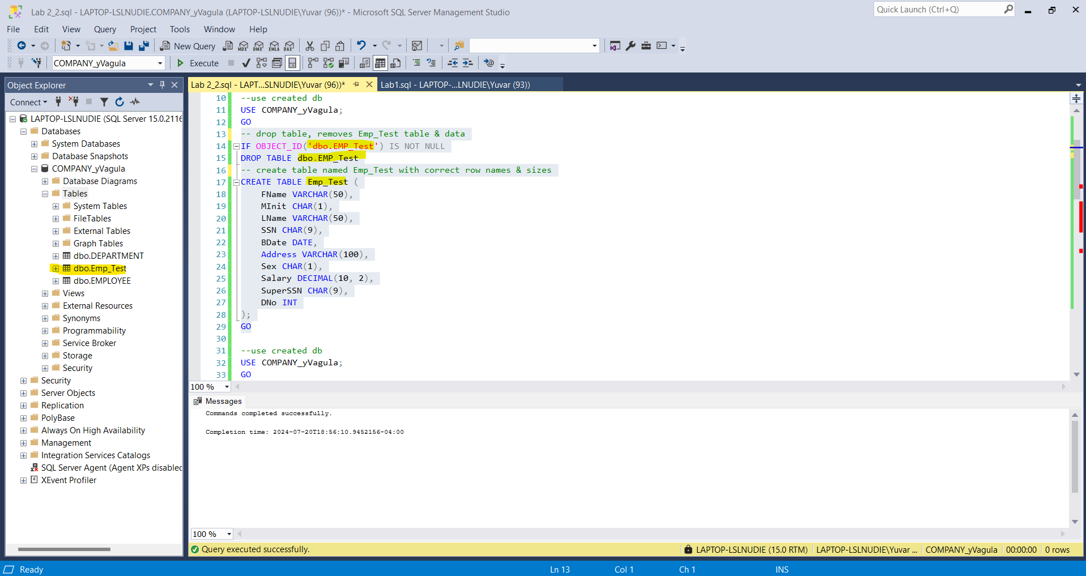

1. Insert a **duplicate tuple** into the **Emp_Test** table

INSERT INTO Emp_Test VALUES ('John', 'B', 'Smith', '123456789', '1955-01-09', '731 Fondren, Houston, TX', 'M', 30000, '987654321', 5);

INSERT INTO Emp_Test VALUES ('John', 'B', 'Smith', '123456789', '1955-01-09', '731 Fondren, Houston, TX', 'M', 30000, '987654321', 5);

1. Insert **invalid PK column values**, duplicate SSN and Null SSN, into the **Emp_Test** table  
     
   -- insert invalid PK values into the Emp_Test table

INSERT INTO Emp_Test VALUES ('Jane', 'D', 'Doe', '123456789', '1980-05-12', '123 Elm St, Houston, TX', 'F', 45000, '987654321', 5);

INSERT INTO Emp_Test VALUES ('Bob', 'C', 'Brown', NULL, '1975-03-22', '456 Oak St, Houston, TX', 'M', 50000, '987654321', 5);  
  
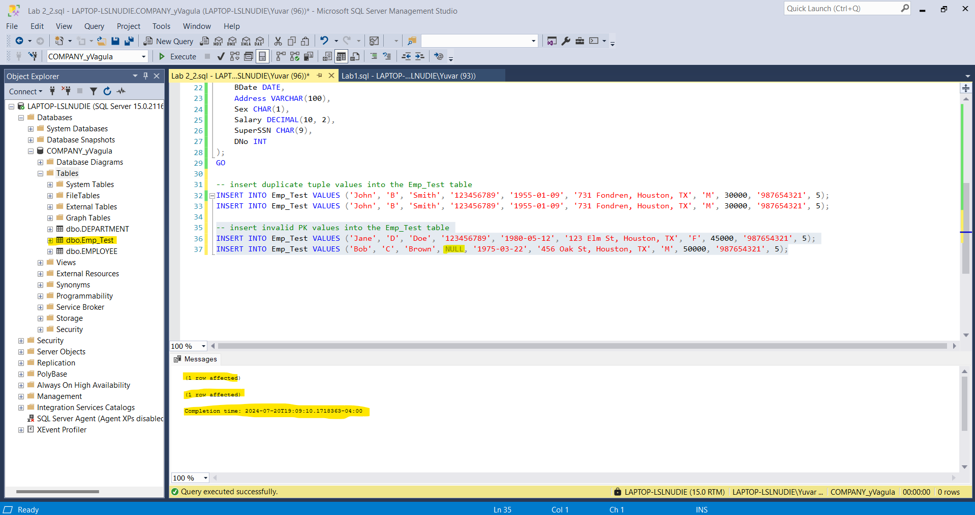

1. Insert **Null values** into the **‘LName’** column

-- insert Null values into the ‘LName’ column

INSERT INTO Emp_Test VALUES ('Alice', 'A', NULL, '987654321', '1990-08-15', '789 Pine St, Houston, TX', 'F', 40000, '987654321', 5);

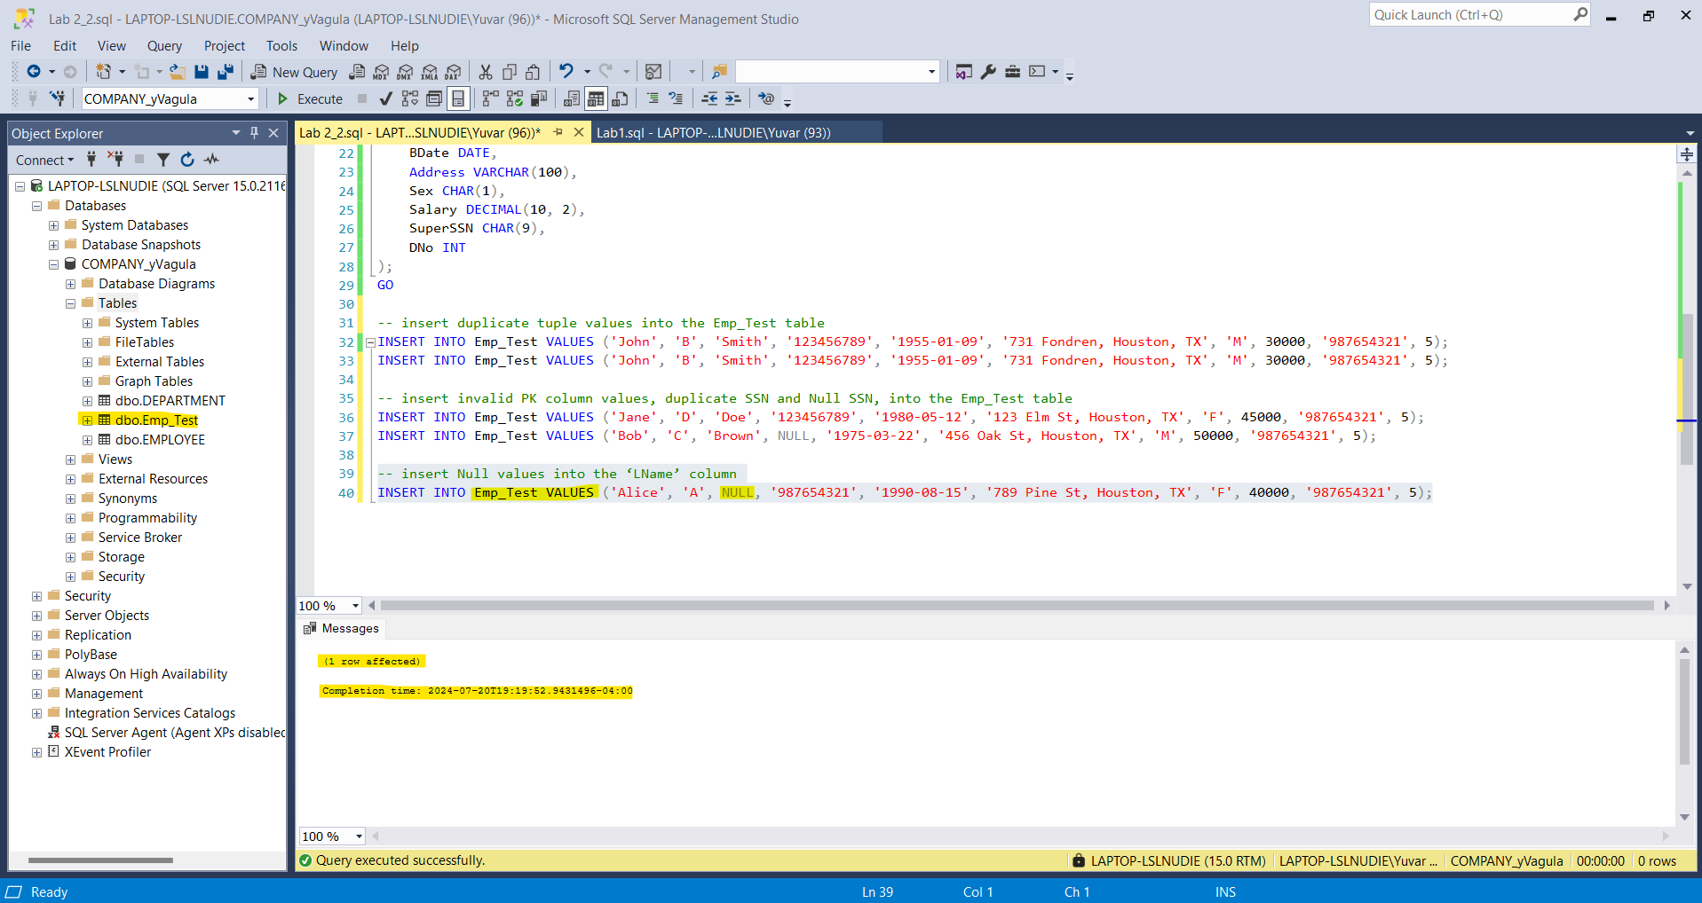

1. Insert invalid data into ‘DNo’

-- Insert invalid data into ‘DNo’

INSERT INTO Emp_Test VALUES ('Eve', 'E', 'Evans', '654321987', '1965-12-30', '321 Birch St, Houston, TX', 'F', 35000, '987654321', NULL);

**

**PART 2:**

1. Create the database schema for the data  
   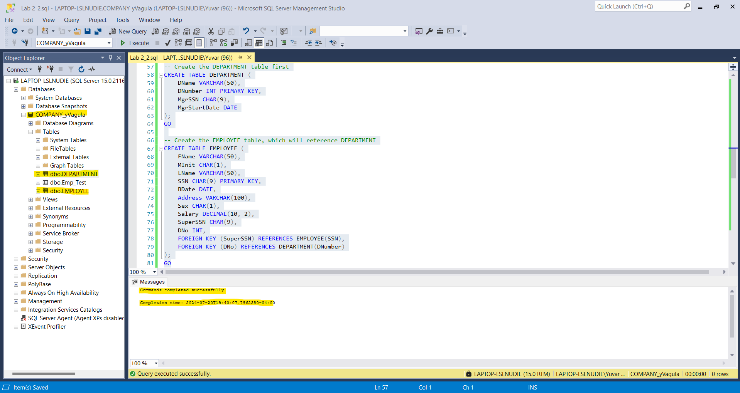

1. Insert the data into the database

-- Insert data into DEPARTMENT table

BEGIN TRY

INSERT INTO DEPARTMENT VALUES ('Headquarters', 1, '888665555', '1971-06-19');

INSERT INTO DEPARTMENT VALUES ('Administration', 4, '987654321', '1985-01-01');

INSERT INTO DEPARTMENT VALUES ('Research', 5, '333445555', '1978-05-22');

INSERT INTO DEPARTMENT VALUES ('Automation', 7, '123456789', '2005-10-06');

END TRY

BEGIN CATCH

END CATCH

GO

-- Insert data into EMPLOYEE table

BEGIN TRY

INSERT INTO EMPLOYEE VALUES ('John', 'B', 'Smith', '123456789', '1955-01-09', '731 Fondren, Houston, TX', 'M', 30000, '987654321', 5);

INSERT INTO EMPLOYEE VALUES ('Franklin', 'T', 'Wong', '333445555', '1945-12-08', '638 Voss, Houston, TX', 'M', 40000, '888665555', 5);

INSERT INTO EMPLOYEE VALUES ('Joyce', 'A', 'English', '453453453', '1962-07-31', '5631 Rice, Houston, TX', 'F', 25000, '333445555', 5);

INSERT INTO EMPLOYEE VALUES ('Ramesh', 'K', 'Narayan', '666884444', '1952-09-15', '975 Fire Oak, Humble, TX', 'M', 38000, '333445555', 5);

INSERT INTO EMPLOYEE VALUES ('James', 'E', 'Borg', '888665555', '1927-11-10', '450 Stone, Houston, TX', 'M', 55000, NULL, 1);

INSERT INTO EMPLOYEE VALUES ('Jennifer', 'S', 'Wallace', '987654321', '1931-06-20', '291 Berry, Bellaire, TX', 'F', 43000, '888665555', 4);

INSERT INTO EMPLOYEE VALUES ('Ahmad', 'V', 'Jabbar', '987987987', '1959-03-29', '980 Dallas, Houston, TX', 'M', 25000, '987654321', 4);

INSERT INTO EMPLOYEE VALUES ('Alicia', 'J', 'Zelaya', '999887777', '1958-07-19', '3321 Castle, Spring, TX', 'F', 25000, '987654321', 4);

END TRY

BEGIN CATCH

END CATCH

GO

-- Insert data into DEPENDENT table

BEGIN TRY

INSERT INTO DEPENDENT VALUES ('123456789', 'Alice', 'F', '1978-12-31', 'Daughter');

INSERT INTO DEPENDENT VALUES ('123456789', 'Elizabeth', 'F', '1957-05-05', 'Spouse');

INSERT INTO DEPENDENT VALUES ('123456789', 'Michael', 'M', '1978-01-01', 'Son');

INSERT INTO DEPENDENT VALUES ('333445555', 'Alice', 'F', '1976-04-05', 'Daughter');

INSERT INTO DEPENDENT VALUES ('333445555', 'Joy', 'F', '1948-05-03', 'Spouse');

INSERT INTO DEPENDENT VALUES ('333445555', 'Theodore', 'M', '1973-10-25', 'Son');

INSERT INTO DEPENDENT VALUES ('987654321', 'Abner', 'M', '1932-02-29', 'Spouse');

END TRY

BEGIN CATCH

END CATCH

GO

-- Insert data into DEPT_LOCATIONS table

BEGIN TRY

INSERT INTO DEPT_LOCATIONS VALUES (1, 'Houston');

INSERT INTO DEPT_LOCATIONS VALUES (4, 'Stafford');

INSERT INTO DEPT_LOCATIONS VALUES (5, 'Bellaire');

INSERT INTO DEPT_LOCATIONS VALUES (5, 'Sugarland');

INSERT INTO DEPT_LOCATIONS VALUES (5, 'Houston');

END TRY

BEGIN CATCH

END CATCH

GO

-- Insert data into PROJECT table

BEGIN TRY

INSERT INTO PROJECT VALUES ('ProductX', 1, 'Bellaire', 5);

INSERT INTO PROJECT VALUES ('ProductY', 2, 'Sugarland', 5);

INSERT INTO PROJECT VALUES ('ProductZ', 3, 'Houston', 5);

INSERT INTO PROJECT VALUES ('Computerization', 10, 'Stafford', 4);

INSERT INTO PROJECT VALUES ('Reorganization', 20, 'Houston', 1);

INSERT INTO PROJECT VALUES ('Newbenefits', 30, 'Stafford', 4);

END TRY

BEGIN CATCH

END CATCH

GO

-- Insert data into WORKS_ON table

BEGIN TRY

INSERT INTO WORKS_ON VALUES ('123456789', 1, 32.5);

INSERT INTO WORKS_ON VALUES ('123456789', 2, 7.5);

INSERT INTO WORKS_ON VALUES ('333445555', 2, 10);

INSERT INTO WORKS_ON VALUES ('333445555', 3, 10);

INSERT INTO WORKS_ON VALUES ('333445555', 10, 10);

INSERT INTO WORKS_ON VALUES ('333445555', 20, 10);

INSERT INTO WORKS_ON VALUES ('453453453', 1, 20);

INSERT INTO WORKS_ON VALUES ('453453453', 2, 20);

INSERT INTO WORKS_ON VALUES ('666884444', 3, 40);

INSERT INTO WORKS_ON VALUES ('888665555', 20, NULL);

INSERT INTO WORKS_ON VALUES ('987654321', 20, 15);

INSERT INTO WORKS_ON VALUES ('987654321', 30, 20);

INSERT INTO WORKS_ON VALUES ('987987987', 10, 35);

INSERT INTO WORKS_ON VALUES ('987987987', 30, 5);

INSERT INTO WORKS_ON VALUES ('999887777', 10, 10);

INSERT INTO WORKS_ON VALUES ('999887777', 30, 30);

END TRY

BEGIN CATCH

END CATCH

GO  
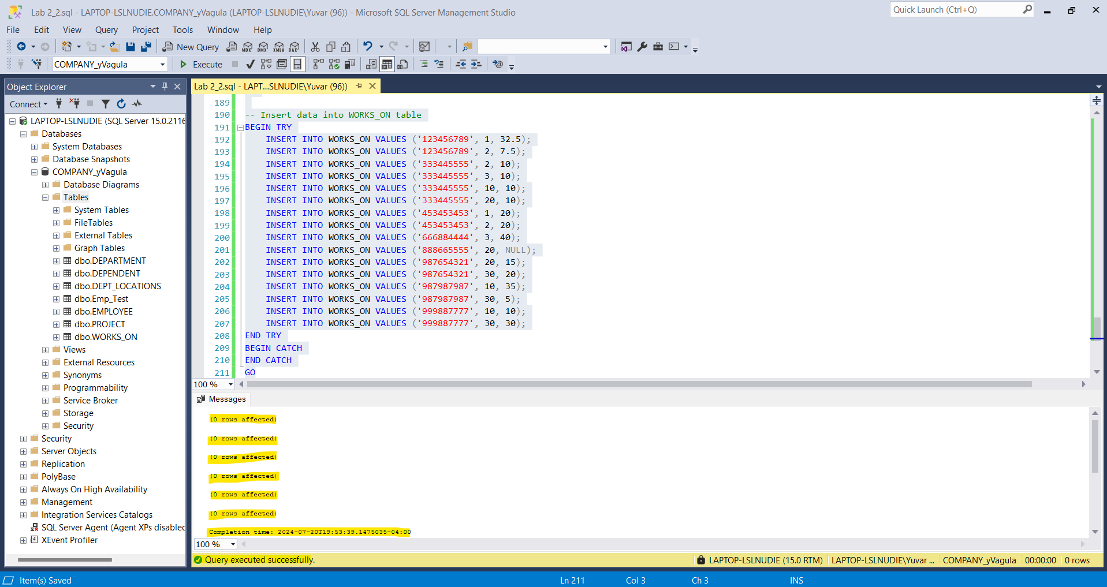

1. Now test the constraints with the same invalid data from part 1

-- Duplicate PK value

INSERT INTO EMPLOYEE VALUES ('Jane', 'D', 'Doe', '123456789', '1980-05-12', '123 Elm St, Houston, TX', 'F', 45000, '987654321', 5);

-- Null in PK column

INSERT INTO EMPLOYEE VALUES ('Bob', 'C', 'Brown', NULL, '1975-03-22', '456 Oak St, Houston, TX', 'M', 50000, '987654321', 5);

-- Null in Not Null column

INSERT INTO EMPLOYEE VALUES ('Alice', 'A', NULL, '987654321', '1990-08-15', '789 Pine St, Houston, TX', 'F', 40000, '987654321', 5);

-- Non-existing PK value in FK column

INSERT INTO WORKS_ON VALUES ('123456780', 1, 32.5);

**We should be getting errors to make sure that the data is safe and secured. There should be no incorrect values being entered into the tables.**

**Database Diagram:**  
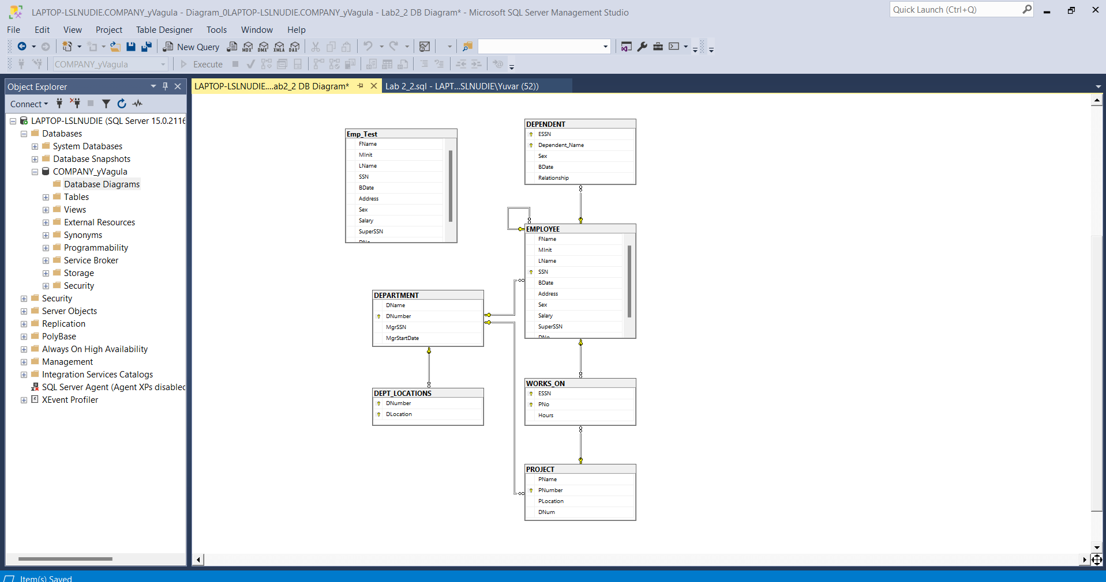

**PROOF OF PATH AND FILENAME**

